UNIVERSITY OF WAH (UOW)

DEPARTMENT OF COMPUTER SCIENCE



BSCS 3RD B

REG #: UW-24-CS-BS-088

SUBMITTED BY: SAADI SAFDAR

SUBMITTED TO: SIR. HASSAN SHAFAQAT

COURSE TITLE: COMPUTER NETWORKS

COURSE CODE: CS – 241 L

LAB REPORT # 12

Lab Overview:
In this lab, a network topology was created using 5 routers, 5 switches, and 15 end devices (PCs). The objective was to establish proper connectivity through correct cabling, interface configuration, IP addressing, and implementation of RIP dynamic routing.

Network Setup Details:

Devices Used
- 5 Routers
- 5 Switches
- 15 PCs

Connections
- Router-to-router: Connected using Serial DCE cables.
- Router/PC-to-switch: Connected using FastEthernet cables.
- Router-to-PC: Connected using Copper Cross-over cables.
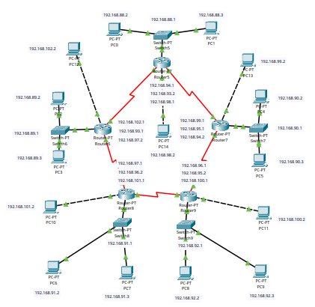

IP Addressing:

PCs Connected to Switches

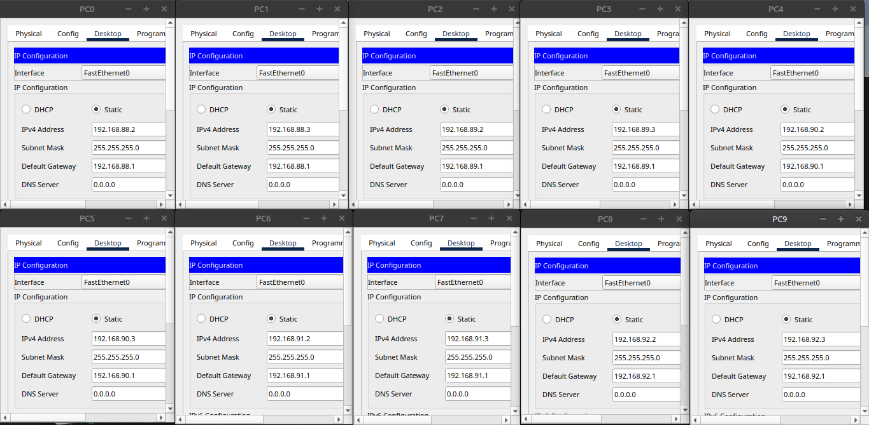
- PCs Connected Directly to Routers

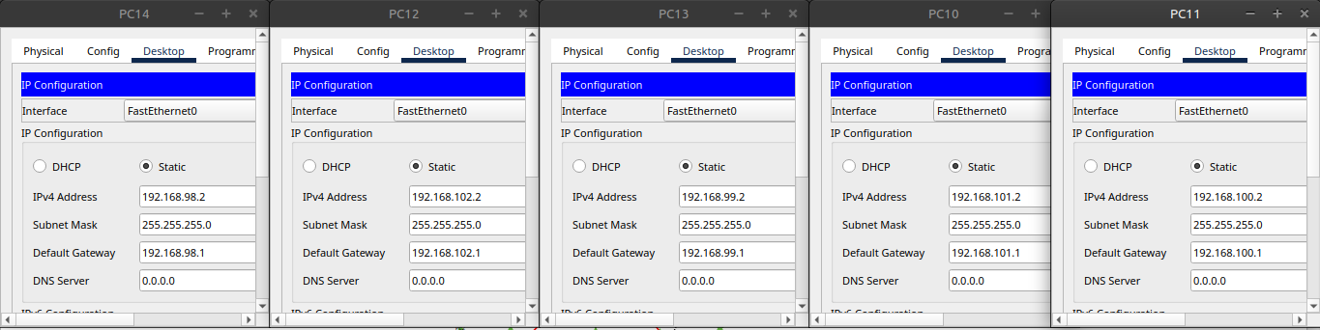

Router Interface Configuration:

FastEthernet 0/0 Interface IPs
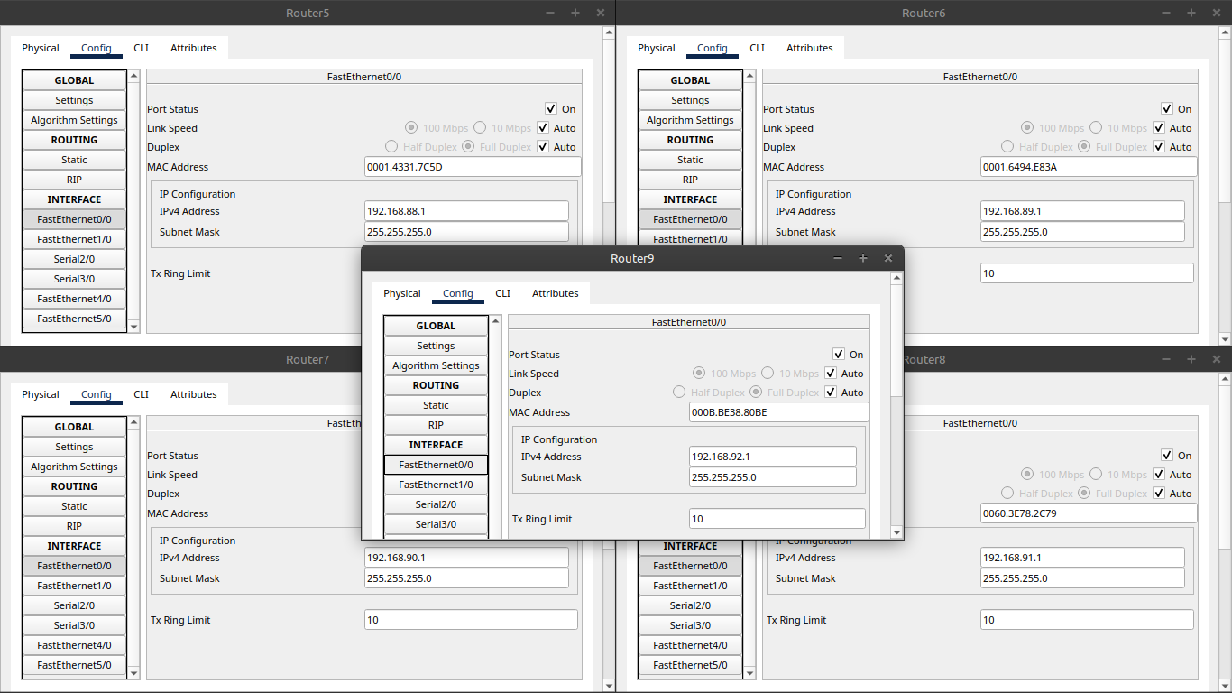

FastEthernet 1/0 Interface IPs
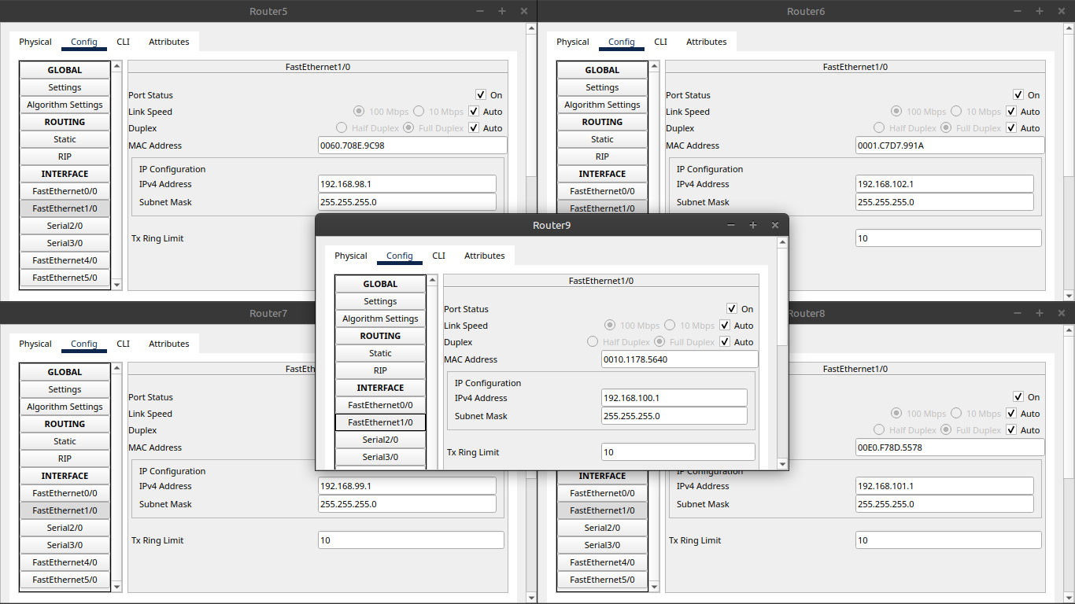

Serial 2/0 Interface IPs
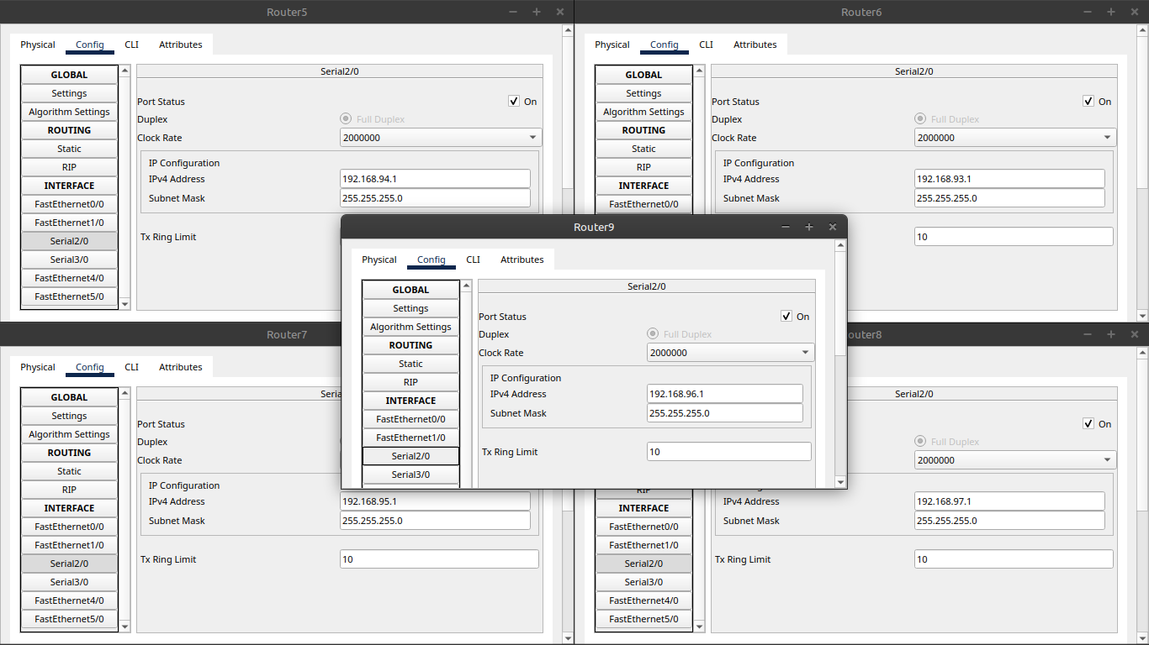
- Serial 3/0 Interface IPs
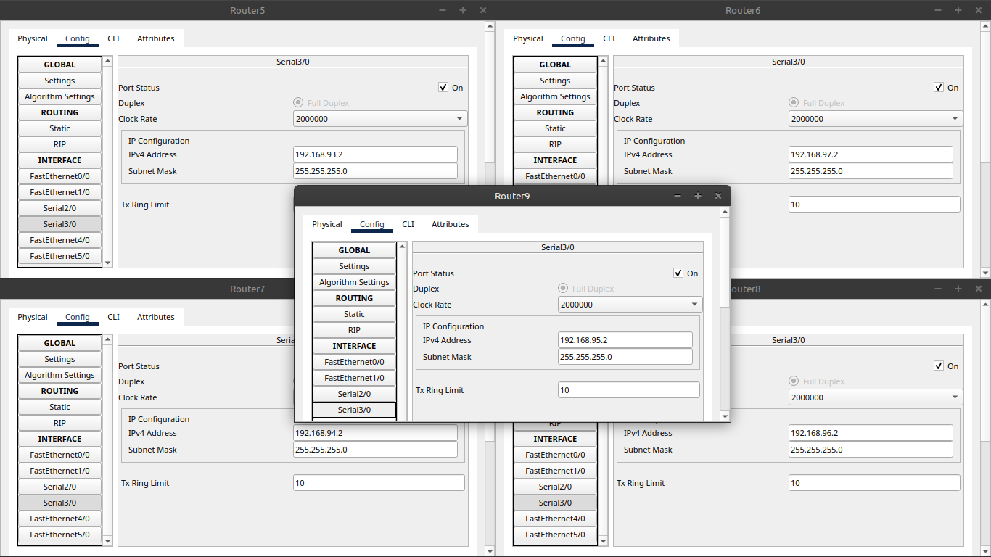

Dynamic Routing: RIP was configured on all routers to enable automatic exchange of routing information between networks.
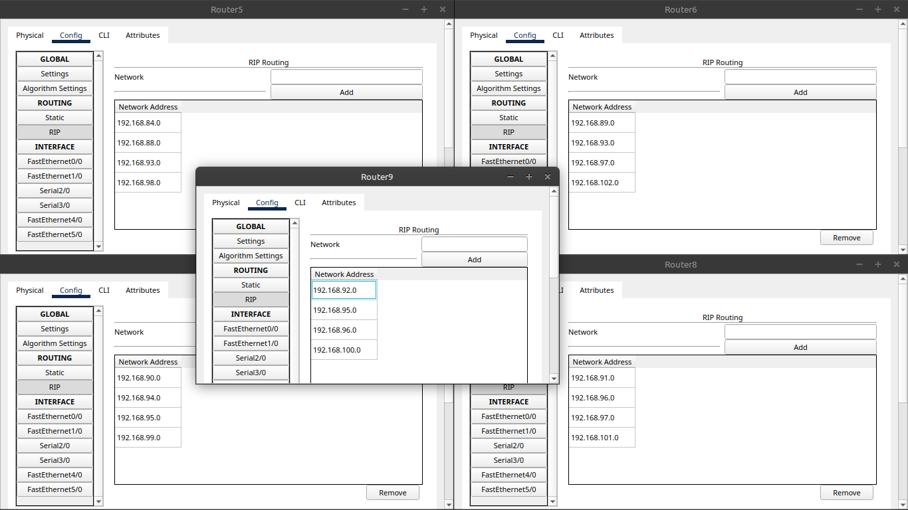
Results: All devices successfully established connectivity across the network. End-to-end communication was validated through successful pings between PCs connected to different routers and switches.
